Name: _______________________ Date: _____________

Parachute Drop

Goal: To build a parachute that falls as slow as possible off the High School bleachers.

Partners name: ____________________
Design/Build:
Materials:
- __________________

- ___________________

- ___________________

- ___________________

- ___________________ Sample Drag Coefficients:
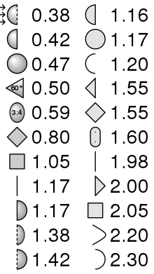

Pre Building Ideas- bigger drag coefficient is better!

Measurements:

Mass (grams): __________/1000=________kg
(measure on electronic balance)

Cross Sectional Area (cm²): ____/10000cm² =
= ________ m²_
(approximate as length times width and convert)

Estimated Drag Coefficient (choose from samples →)
(kg/m³): _________
(choose for a shape from the table, which shows drag coefficient given air flow from left to right).
Measure:
What is the measured height and drop time from which your parachute was dropped?

Height (meters): _________ Drop Time (seconds): __column F______
Class Times Template: https://docs.google.com/spreadsheets/d/1wH1dve-RyIx0QGxiNWoyAu8HLSn7BianzFpQY2omstE/edit?usp=sharing
Model: Use file 202S-5 Terminal Velocity:
You will now input these measured values into the spreadsheet model in the following cells:
Mass in kilograms in cell A2 (use your measured value divided by 1000, not 0.025)
Cross Sectional Area in (m²) in cell B2 (your CSA (in cm²) divided by 10000, not 0.025)
Drag coefficient in cell C2 (use your chosen value from the samples, not 1.1)

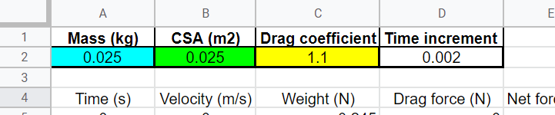

You can read your theoretical drop time from the simulation spreadsheet (cell H2) and see the velocity level off on the graph or read the numerical value from column B once it levels off.

- What is the theoretical drop time from the ______ meters drop height? (Enter in cell G2, the time is in cell H2)

- What is the maximum (terminal) velocity? (read from graph or scroll down in column B) Answer: ________ m/sec

- During which time(s) is the parachute experiencing unbalanced forces? (highlight)
- Before it is released
- When it is first speeding up
- When it falls at constant velocity

- During which time(s) is the parachute experiencing balanced forces? (highlight)
  - Before it is released
  - When it is first speeding up
  - When it falls at constant velocity

- When an object weighing 5 Newtons falls at terminal velocity, what is the magnitude of the drag force acting on it? Hint: Forces are balanced! ________ Newtons

Application:
Observe the graph of velocity vs. time below of an object that is falling and speeding up until it reaches terminal velocity:

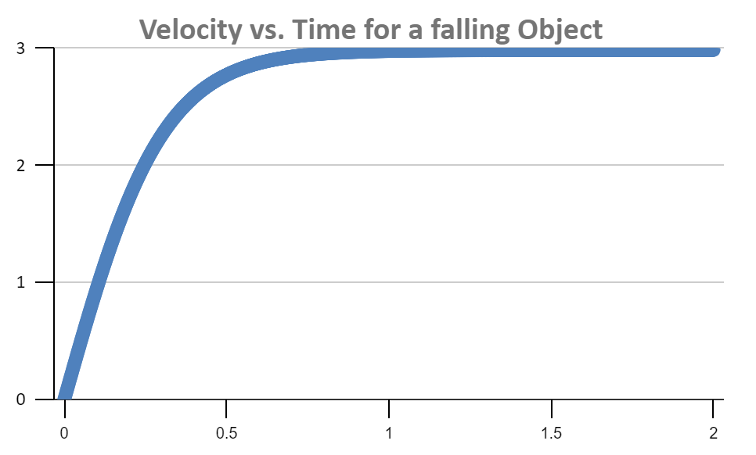
Label on Graph: At which point does the falling object reach a constant velocity?
Drag forces on falling objects: A. B. C.

gravity

Which diagram shows the following (enter the letter (A, B or C) with the appropriate force diagram in the blanks below.
_____ a light object experiencing a bigger drag force (slowing down)
_____ a heavy object experiencing a smaller drag force (speeding up)
_____ a heavy object falling at constant velocity (acceleration is 0)

